# Employee View: Goal-Setting

**Standard Form in PeopleSoft 9.2 ePerformance**

Starting in FY18 the Standard Form will have a vastly difference experience for both employees and managers. Details on this update and an example of the Goal Setting view from the employee’s perspective is below.

# cid:image001.png@01D2FFB9.224C15D0

* Ratings & comments were removed from the goals & competencies sections
* Removed “Due Date” & “Stretch Goal” options from Job & Performance Goals
* Removed “Due Date” option from Professional Growth & Development Goals
* Removed some text & images

# Employee View: Self-Evaluation

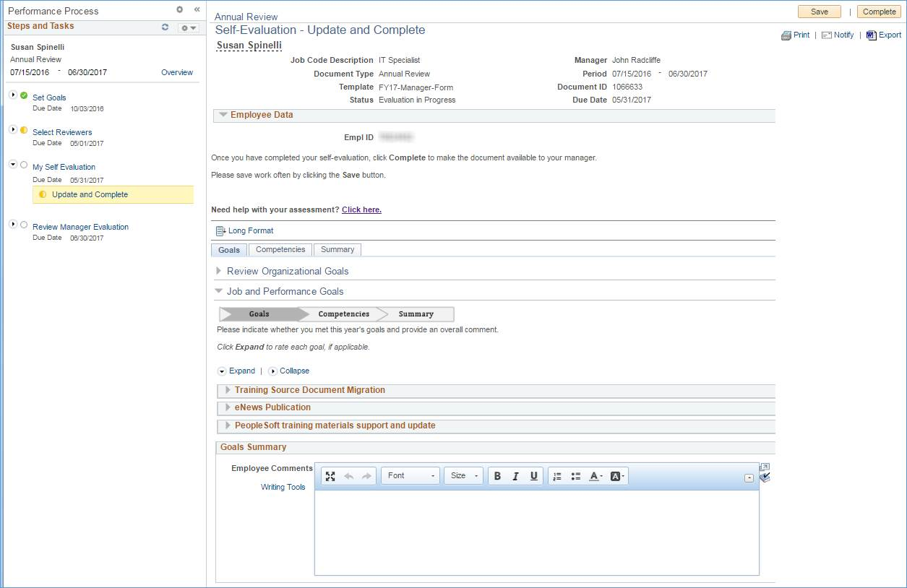After the 9.2 Upgrade, employees continue to be able to complete the optional Peer Review and optional Self-Evaluation sections directly within the Annual Review in PeopleSoft. An example of the Self-Evaluation view from the employee’s perspective is below.

# Manager View: Manager Evaluation

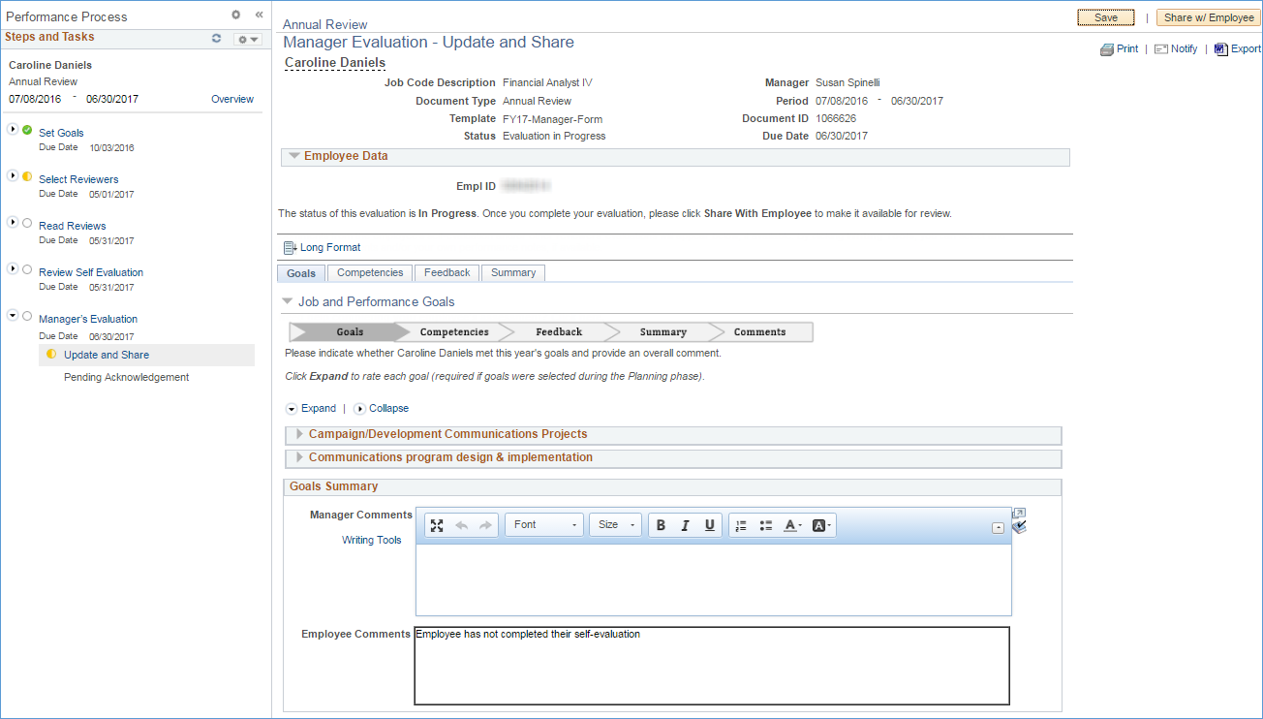After the 9.2 Upgrade, managers can easily incorporate any Peer Review feedback or review the Self Evaluation while completing their review. An example of an employee’s comments on their goals from their Self-Evaluation being pulled into the Manager’s Evaluation is below.